NINJAGO: Ghost Broadcast
Steganography · Upper-Medium to Hard
Description | I went to the flea market and someone was selling a VHS copy of Ninjago! I decided to pick it up, but when I played it, I realized it was a bit weird. My original VHS copy is way faster. To be honest, someone back in elementary school told me about a secret copy of Ninjago released on the market back in 2010. I wonder if this is the copy. Can you compare the two VHS tapes and find the secret?
Files | Single Docker container. Run from this folder:  docker build -t rowdy-ninjago:2026 challenge  docker run -d --name rowdy-bbc-2026 --read-only \  --cap-drop=ALL --security-opt=no-new-privileges \  --pids-limit=64 --memory=256m \  -p 18103:18103 rowdy-ninjago:2026  Open http://localhost:18103. Players receive the URL; both lossless recordings and their frame index are downloadable from Tape Library. All equipment and media run locally. docker restart rowdy-bbc-2026 resets the stateless server; Reset desk clears browser controls and recordings. Keep organizer/, screenshots/ and this submission document private. Regeneration and checks are organizer-only.
Hint(s) | 1. The same recognizable moments appear on both tapes. Compare when they happen, rather than trusting the counters to agree.  2. Match two moments to find the playback-rate difference. A later shot appears on only one tape, so the offset changes after that splice.  3. Difference removes the shared picture and leaves a moving light. Hold keeps the brightest pixels of the combined output; collect both aligned portions.
Walkthrough | Sync the two VHS tapes by adjusting their positions and playback speeds until matching scenes appear at the same time. Select Difference to leave only the hidden light trail, and use Gain if it looks too dim. Record both sections, adjusting the sync after the extra scene on Tape B. Replay the recording with Hold enabled so the trail builds into a complete picture. Read the flag and submit it under Broadcast authorization.  1. Select View tapes to see both recordings on the television. In the decks' FRAME boxes, compare A 48 with B 78: both reach the Fire Temple shot. Compare A 240 with B 270: both reach the dragon shot. Their times are 2.000 / 3.120 seconds and 10.000 / 10.800 seconds.  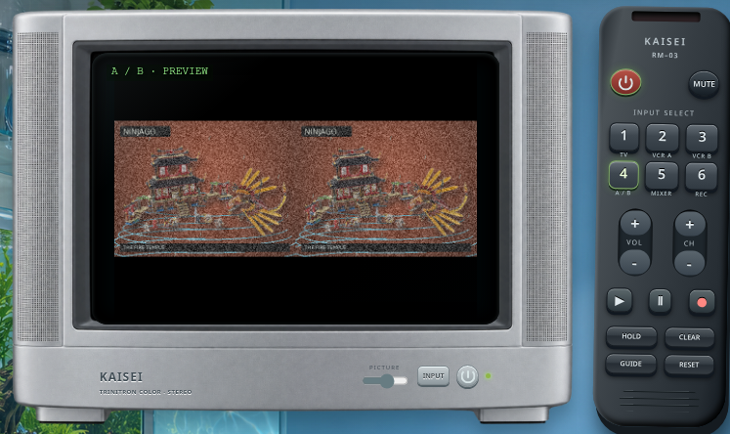  2. B covers 7.680 seconds while A covers 8.000, so set B RATE to 96%; leave A at 100%. Use B time = 0.96 × A time + offset. The initial offset is 1.200 seconds. Select DIFFERENCE, then OUTPUT on the mixer. Matching frames now produce a small moving light on black.  3. Set A FRAME = 0, B FRAME = 30, and A OUT = 287. Leave Hold off. Press REC once to arm the output recorder, then PLAY BOTH. The decks stop at A's OUT point; the recorder contains 0288 FRAMES.  4. B has an extra two-second Kai shot before the Green Ninja scene. That shared scene begins at A 288 and B 368, so the new offset is 3.200 seconds. Set those FRAME values and A OUT = 575. Keep B at 96% and the recorder armed. Press PLAY BOTH again. The recorder now contains 0576 FRAMES.  5. Press REC to disarm it. Press HOLD, then the output recorder's PLAY. Hold takes the maximum brightness at each pixel across the recorded Difference frames. The moving trace builds a ninja mask, Spinjitzu rings and the complete authorization. Both aligned portions are needed: each contains different complete characters.  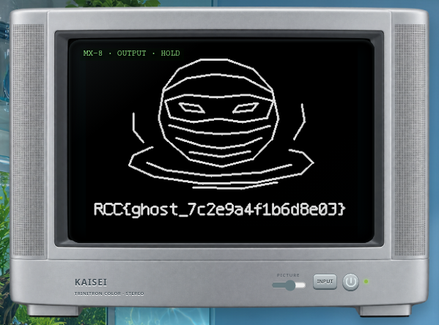  6. Read RCC{ghost_7c2e9a4f1b6d8e03} from the picture. Select Enter authorization, enter the code in Broadcast authorization, and press Restore.  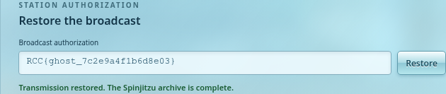  The same result can be obtained with live Difference + Hold: pause and turn Hold off while re-cueing the tapes at the splice, then turn it back on. Clear erases the accumulated image. External analysis is also supported: the reference receiver discovers picture correspondences from the two public FFV1 downloads, infers the timing segments and accumulates their actual pixel differences; it reads no private alignment or flag fixture.
Flag | RCC{ghost_7c2e9a4f1b6d8e03}

